Kruskal’s Algorithm

SmallGraph1

"kruskal" : {  
 "algorithm" : "Kruskal",  
 "total_cost" : 10.0,  
 "execution_time_ms" : 1,  
 "operations" : 9,  
 "vertex_count" : 4,  
 "edge_count" : 5,  
 "mst_edges" : [ {  
 "from" : "B",  
 "to" : "C",  
 "weight" : 2.0  
 }, {  
 "from" : "A",  
 "to" : "C",  
 "weight" : 3.0  
 }, {  
 "from" : "B",  
 "to" : "D",  
 "weight" : 5.0  
 } ]  
}

SmallGraph2

"kruskal" : {  
 "algorithm" : "Kruskal",  
 "total_cost" : 11.0,  
 "execution_time_ms" : 0,  
 "operations" : 11,  
 "vertex_count" : 5,  
 "edge_count" : 6,  
 "mst_edges" : [ {  
 "from" : "B",  
 "to" : "C",  
 "weight" : 1.0  
 }, {  
 "from" : "A",  
 "to" : "B",  
 "weight" : 2.0  
 }, {  
 "from" : "C",  
 "to" : "E",  
 "weight" : 3.0  
 }, {  
 "from" : "D",  
 "to" : "E",  
 "weight" : 5.0  
 } ]  
}

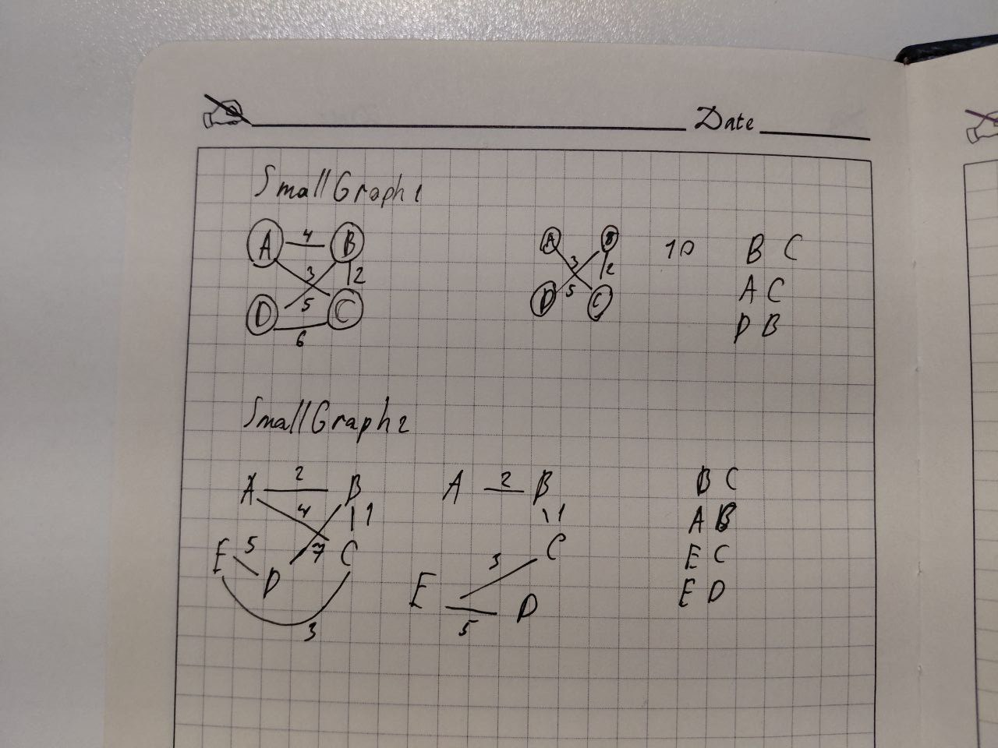

Prim’s Algorithm

SmallGraph1

"prim" : {  
 "algorithm" : "Prim",  
 "total_cost" : 10.0,  
 "execution_time_ms" : 6,  
 "operations" : 9,  
 "vertex_count" : 4,  
 "edge_count" : 5,  
 "mst_edges" : [ {  
 "from" : "A",  
 "to" : "C",  
 "weight" : 3.0  
 }, {  
 "from" : "C",  
 "to" : "B",  
 "weight" : 2.0  
 }, {  
 "from" : "B",  
 "to" : "D",  
 "weight" : 5.0  
 } ]  
}

SmallGraph2

"prim" : {  
 "algorithm" : "Prim",  
 "total_cost" : 11.0,  
 "execution_time_ms" : 0,  
 "operations" : 11,  
 "vertex_count" : 5,  
 "edge_count" : 6,  
 "mst_edges" : [ {  
 "from" : "A",  
 "to" : "B",  
 "weight" : 2.0  
 }, {  
 "from" : "B",  
 "to" : "C",  
 "weight" : 1.0  
 }, {  
 "from" : "C",  
 "to" : "E",  
 "weight" : 3.0  
 }, {  
 "from" : "E",  
 "to" : "D",  
 "weight" : 5.0  
 } ]  
}

